Discussion Assignment Unit 6
What is AJAX?
AJAX (Asynchronous JavaScript and XML) is a web development technique that enables web applications to communicate with a server asynchronously without needing to refresh the entire webpage. This method facilitates the creation of dynamic and highly interactive user interfaces, improving the overall user experience (IBM, 2021). Instead of sending entire HTML pages, AJAX enables the transmission of small amounts of data between the client and the server, significantly enhancing application responsiveness.
What are the main characteristics of this technology?
- Asynchronous communication: AJAX allows data exchange with the server without blocking the user interface, meaning users can continue interacting with the application while the data is being processed (IBM, 2021).
- Dynamic content updates: Only the necessary portions of a web page are updated, reducing bandwidth consumption and speeding up response times (IBM, 2021).
- Enhanced user experience: By enabling smooth and real-time updates, AJAX minimizes delays and provides a more seamless browsing experience (IBM, 2021).
- Platform independence: AJAX works across multiple operating systems and browsers, ensuring accessibility (IBM, 2021).
- Standardized technology stack: AJAX integrates seamlessly with well-established technologies like HTML, CSS, JavaScript, and XML/JSON (IBM, 2021).
What are the existing standards that AJAX is based on?
According to IBM (2021), AJAX relies on the following established web standards to function:
- HTML/XHTML and CSS: These are used to create and style the structure of web pages.
- DOM (Document Object Model): Facilitates dynamic interaction and updates to the content, structure, and style of web pages.
- XML-Http Request Object: This JavaScript object is central to AJAX operations, enabling asynchronous communication between the client and the server.
- JavaScript: Plays a critical role in implementing the client-side logic and interaction with the server.
- XML and JSON: These are the primary data formats used for server responses in AJAX applications. JSON is often preferred due to its lightweight nature and compatibility with JavaScript.
Explain how AJAX works.
- User Action: A user interaction, such as clicking a button or typing in a search box, triggers an AJAX request.
- Request Generation: JavaScript uses the XML-Http Request object to create and send an asynchronous request to the server.
- Server Processing: The server processes the request, retrieves the required data, and formats it (usually in JSON or XML).
- Response Handling: Once the server sends back the response, JavaScript processes the returned data without reloading the page.
- Dynamic Update: The necessary parts of the web page are updated dynamically using DOM manipulation.
Figure 1: How AJAX works
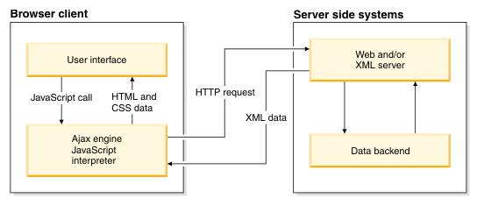
Source: IBM, 2021
Reference
IBM. (2021, March 2). What is Ajax? IBM - United States. https://www.ibm.com/docs/en/rational-soft-arch/9.7.0?topic=page-asynchronous-javascript-xml-ajax-overview

